**PROJECT: WANDERING IN THE WOODS**

Developed by:-

Nidish Chandra Birudaraju

Anuradha Gude

Chaitanya Meda

Vanitha Sannaobappa

INTRODUCTION

MAIN OBJECTIVE OF STUDY

A ***blueprint*** of the project where we have to develop a game named “*Wandering in the Woods*” is presented to our reader throughthis documentation. Features of the game are estimated after the proper analysis of given case study and outcomes are noted down in this report.

Preparation of a final product comprises perceptions, strategies and methods which altogether reflects the game interface in a tentative manner. Subsequently, this tentative form of product in the premier stage can be interpreted as a blueprint when the aforementioned aspects of the project are described in the form of a document.

EVALUATION OF PROJECT

Wandering in Woods is a game application that is being developed with the intention of computer simulation. A weakness in mathematical concepts and calculation has been found among the elementary students.

The game app incorporates the features to assist the elementary student in the learning process of mathematical concepts. In other words, the game is meant to help K-8 students in order to develop computational thoughts.

PROCESS MODEL

In order to optimize the business process of organization, each phase of the process needs to be visualized to explore its current functionalities. An Evolutionary Process Model (EPM) is implemented in the software project cycle so that I can maintain the iteration and increment together.

**Starting Tentative Requirement**

**Specification**

**Development**

**Validation**

**Initial Version**

**Intermediate Version**

**Final Version**

EVALUATION OF USE CASE

A perception plays a crucial role in the development of game application because it exploits the behavior of end-user beforehand. Likewise, it becomes necessary for us to understand the perception of students when they play game or interact with it. Use case is a mechanism that describes the activities and behavior of end-user while interacting with game application would be helpful for me to forecast. Subsequently, user’s actions are described on the system by using various use cases.

USE CASE 1: INITIATE GAME

|  |  |
| --- | --- |
| **Identification Number** | 1 |
| **Analysis** | Game would be launched by student so that one can navigate to Home page of game in order to start it. |
| **Actor** | Student |
| **Before Condition** | It becomes mandatory to install the game set up file in the system for initiating it. |
| **Event Flow** | 1. Student creates the setup of game. 2. Explore the various options of games. 3. Initiate game |
| **After Condition** | Game application must exhibit the expected features to student. |

USE CASE 2: PLAY GAME

|  |  |
| --- | --- |
| **Identification Number** | 2 |
| **Analysis** | The use case states about the opening of grid page on system screen where students would make movements. |
| **Actor** | Student |
| **Before Condition** | Student must choose the correct option. |
| **Event Flow** | Student will do the following:  Open Screen>>Click on Option>>Start Game |
| **After Condition** | Grid must appear on the screen |

USE CASE 3: SELECTION OF PHASES

|  |  |
| --- | --- |
| **Identification Number** | 3 |
| **Analysis** | The use case states about the selection of phase or stage of game by student. |
| **Actor** | Student |
| **Before Condition** | Interface must show the three options of stages to student. |
| **Event Flow** | Student will do the following:  Start Game>>Stages of Game>>Selection of Stage>>Play |
| **After Condition** | Selection of phase need to meet the expectation of student. |

USE CASE 4: OBSERVE STATISTICS

|  |  |
| --- | --- |
| **Identification Number** | 4 |
| **Analysis** | The use case showcase the statistics of students played the game and other related aspects. |
| **Actor** | Student |
| **Before Condition** | Statistics will not reveal till student plays the game. |
| **Event Flow** | Student will do the following:  Open the Screen>>Choose Option>>Start playing game>>Complete the game>>Statistics Revealed |
| **After Condition** | Statistics revealed in numeric |

USE CASE 5: REPEAT GAME

|  |  |
| --- | --- |
| **Identification Number** | 5 |
| **Analysis** | The use case states about repetition of opening and playing the game by student. |
| **Actor** | Student |
| **Before Condition** | The game should be played serially. |
| **Event Flow** | Students will do the following: |
| **After Condition** | Student must have the second game after finishing the first one. |

USE CASE 6: EXIT GAME

|  |  |
| --- | --- |
| **Identification Number** | 6 |
| **Analysis** | The use case states a scenario of game where student will exit it. |
| **Actor** | Student |
| **Before Condition** | Student must start and play the game. |
| **Event Flow** | Student will do the following:  Open Interface>>Choose Stage>> Start playing Game>> Exit the game |
| **After Condition** | Student must see the exit option once the level is accomplished. |

USE CASE 7: DIAGONAL MOVEMENT

|  |  |
| --- | --- |
| **Identification Number** | 7 |
| **Analysis** | The use case describes the diagonal movement of student on a grid. |
| **Actor** | Student |
| **Before Condition** | Student must access the grid of game in the system. |
| **Event Flow** | Student will do the following:  Open Game Interface>>Choose option>>Play Game>>Make Diagonal Movement |
| **After Condition** | The object should move diagonally. |

USE CASE 8: RANDOM MOVEMENT

|  |  |
| --- | --- |
| **Identification Number** | 8 |
| **Analysis** | The use case states about the scenario of game when student will make random movement of object on the grid of game interface. |
| **Actor** | Student |
| **Before Condition** | The grid must open up on the game interface in the system. |
| **Event Flow** | Student will do the following:  Open Game App>>Choose Stage>>Start Game>>Make Random movement on grid |
| **After Condition** | The game must finish in a normal process. |

USE CASE 9: GRID CHANGE

|  |  |
| --- | --- |
| **Identification Number** | 9 |
| **Analysis** | The use case conveys the change in the grid size |
| **Actor** | K3-5 Group Student |
| **Before Condition** | Student must belongs to K3-5 group those can choose moderate stage. |
| **Event Flow** | Student of K3-5 group will do the following act:  Open Game Interface>>Choose Moderate Stage>>Start Game>>Play>>Complete the Stage>>Exit Game |
| **After Condition** | Calculation moves made during the play must exhibit the statistics. |

USE CASE 10: PLAY CHALLENGE

|  |  |
| --- | --- |
| **Identification Number** | 10 |
| **Analysis** | The use case states about a challenging phase of game that is overcome by a student. |
| **Actor** | Student |
| **Before Condition** | Student must belong to the K6-8 group. |
| **Event Flow** | Student of K6-8 group will do the following:  Open Game Interface>> Choose Complex Stage of Game>>Play Game>>Overcome the stage>>Exit |
| **After Condition** | Statistics should be generated after completion of this game. |

USE CASE 11: VARIED TECHNIQUES OF WANDERING TEST

|  |  |
| --- | --- |
| **Identification Number** | 11 |
| **Analysis** | The use case states about the various methods to conduct test of the game application. |
| **Actor** | Student |
| **Before Condition** | The student must belong to K6-8 group and they must initiate the game. |
| **Event Flow** | Student of Group K6-8 will do the following:  Open Game Interface>>Choose stage>>Play Game>>Test various techniques of movement>>Complete Game>>Exit |
| **After Condition** | Movements will be counted and statistics will be generated. |

UML MODEL

USE CASE DIAGRAM

In order to explore the dynamic aspects of system, use case diagram is implemented. The diagram helps a developer in determining the roles of actors and approach of these actors to interact with system. Subsequently, the use case diagram for game “Wandering in the Wood” identifies the student as actor. Likewise, start game, play game, view game are instance of use case whose interaction has been depicted in the figure below.

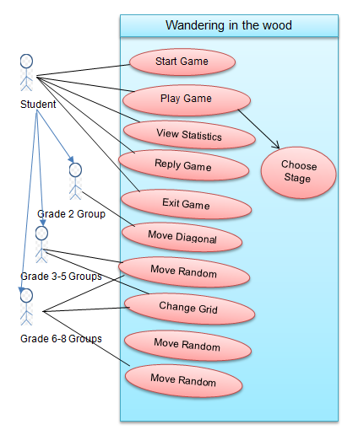

DEPLOYMENT DIAGRAM

Deployment diagram showcase the physical architecture of game application. Subsequently, the hardware components and software platforms used in the development of game application is shown through this diagram. In addition, the diagram also illustrates the communication between hardware and software components.



Browser

Web Server

Application Server

Servlet Application

Database Server

SQL

Actor

CLASS DIAGRAM

Class diagram is specifically used for static representation of game application. The diagram is also used for visual representation of application whose functions can be understood by developer oneself.

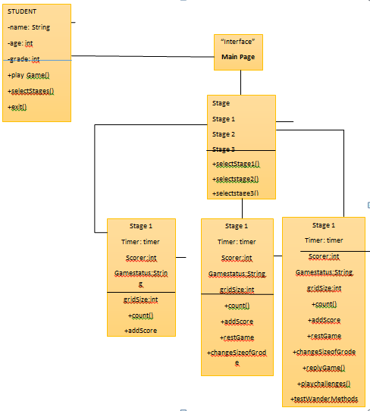

STATE DIAGRAM

State diagram indicate the part exists within a system with respect to the time. A finite state transition has been used to develop a structure in the context of Wandering in Woods game application. For example, the start and end of the game are two states that a student would experience while playing it.

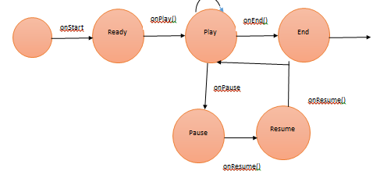

ACTIVITY DIAGRAM

An activity diagram can be considered as advanced form of flow chart used for exploring the attributes of game application. It is pictorial representations that forecast the dynamic features of game like play game, initiate etc.

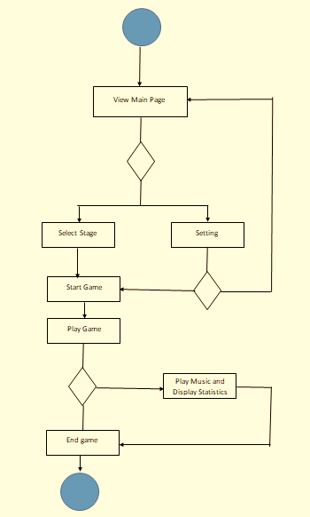

1. **Customer Journey Map**

The customer journey map can be depicted to showcase the interaction of customer with the product. In other words, the experience of customer is described under this section. A business person can visualize the experience of a target customer from this map. The following image showcases the customer journey while playing game on Wander in Woods game application:

